
ATAR Biology

Unit 1: Topic 3
Week 11 – Surveying Populations

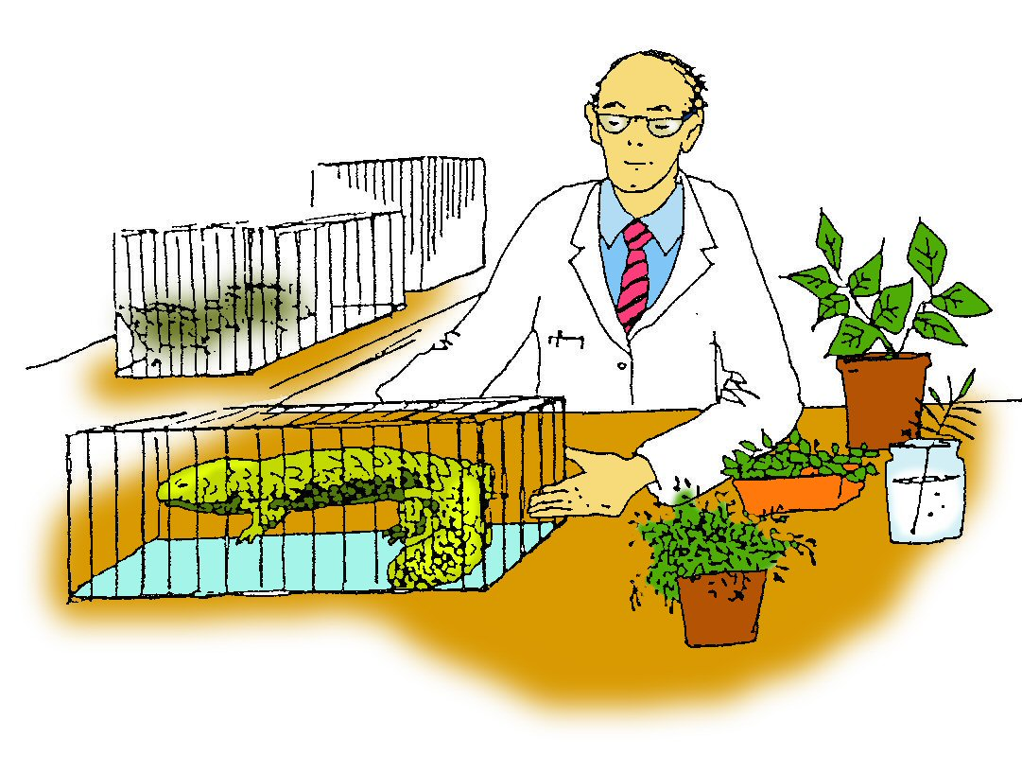

Student Study Notes

Unit Content
- Sampling techniques – quadrats, transects & capture-recapture.
- Contemporary technologies, including satellite sensing and remote monitoring enable improved monitoring of habitat and species population change over time.
- Ethical treatment of animals, including the three strategies of replacement, reduction and refinement, forms the basis of many international guidelines in animal research.
- Conduct investigations, including using ecosystem surveying techniques (quadrats, line transects and capture-recapture) safely, competently and methodically for the collection of valid and reliable data.

Fieldwork: Biologist’s Toolkit
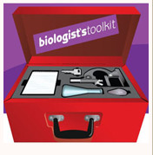
Go to the Fieldwork section in the Biologist’s Toolkit for information on density and mapping distribution then answer the questions below. Read through pages 35-50 to learn how biologists use quadrats and transects.

Capture/recapture
In animal population studies, the capture/recapture method is often used to estimate the number of individuals in a population. A specific number of individuals from the population being studied are captured and labelled (tagged) before being released back into the population.
After enough time has elapsed for the animals to disperse a second sample of the population is captured and the number of tagged individuals noted. From this data, the density of the population can be calculated.

Fieldwork: Biologist’s Toolkit
Go to the Fieldwork section in the Biologist’s Toolkit for information on capture-recapture and animal surveying techniques. Read through pages 51-64 then use this information to help you complete the questions below.

PRACTICE QUESTIONS:

Density and distribution activity

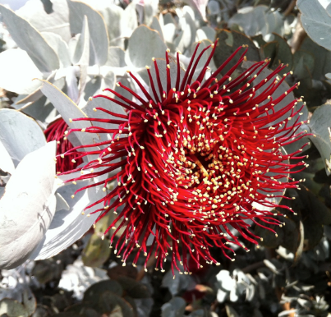
Eucalyptus macrocarpa is an endemic plant species found in the south western Western Australia. Mature plants vary from 0.8m to 5m in height and have a sprawling form. The species is known to grow on white or grey sandy loam soils that overlay clays rich in iron and aluminium oxides. Many areas of the plants former distribution have been cleared for farmland.

- A group of students on a Biology camp in the Kulin area, a region well known for the plant, took a walk along the 1.1 km long Macrocarpa Trail (see Image 1). On their walk they identified a number of individuals of the species.

Image 1: Macrocarpa Trail in bushland adjoining Kulin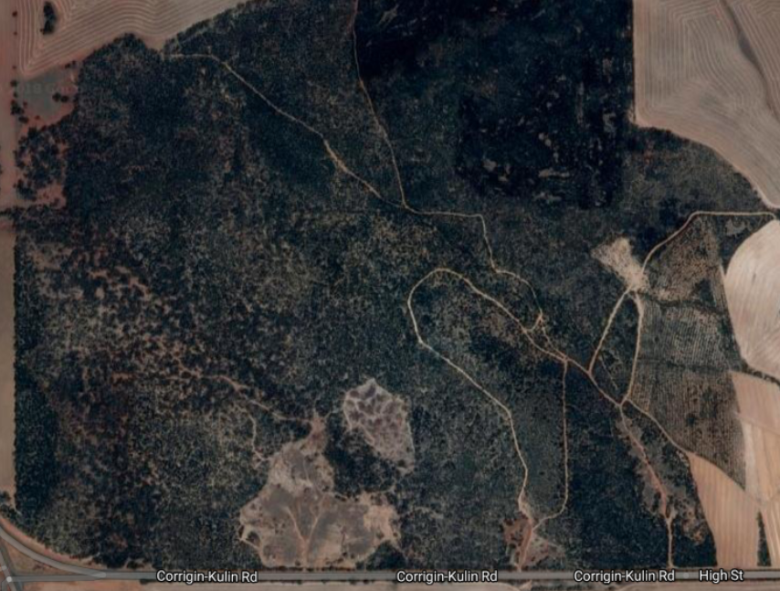
Macrocarpa Trail

The students decided they wanted to better understand the population density, size and distribution of Eucalyptus macrocarpa.

- State the formula used to measure population density.

The students marked out an area of the bushland with an area of 100m x 100m. Using a drone, they took an aerial photo of the patch. The students studied the photo and identified all plants with pale leaf colour as Eucalyptus macrocarpa. They used the data to estimate the population size.

- Would this be a reliable method to estimate population size? Explain.

- Would you expect Eucalyptus macrocarpa to be uniformly distributed across the reserve? Explain.

Although the arum lily, Zantedeschia aethiopica, has attractive ﬂowers, it is considered a widespread weed in Western Australia and has even spread to some offshore islands.
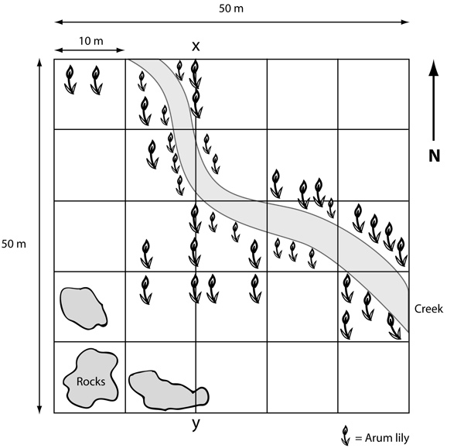
The arum lily is toxic to animals and a local ecologist is concerned as arum lilies have been identiﬁed in an area not far from a settlement. The ecologist wishes to establish the extent of infestation before starting a program to eradicate the weed.
The ecologist has set a grid of quadrats in a plot (50 metres x 50 metres) in the area where the arum lilies have been identiﬁed.

The data is shown in the grid opposite.

- What is the density of arum lilies in the grid area? Show your calculation.

The ecologist then pegged a transect along the line x-y
- What length of cord would be needed to ‘draw’ a transect line along x-y?

- Sketch a transect profile along x-y, showing the distribution of arum lilies.

- Suggest a factor which may inﬂuence the distribution of the arum lily.

- How could the ecologist increase the reliability of the conclusions about the factors affecting distribution of the arum lily?

- A student wanted to know how many flowers there were in a 50 m² field and threw enough quadrats to cover 10 m², finding 40 flowers. How could the student calculate the estimated number of flowers in the whole field?

- The lilac is a flowering plant found in woodlands. Describe how you could estimate the number of lilacs in a small woodland area.

Source: AQA A-Level Biology Jan 2012
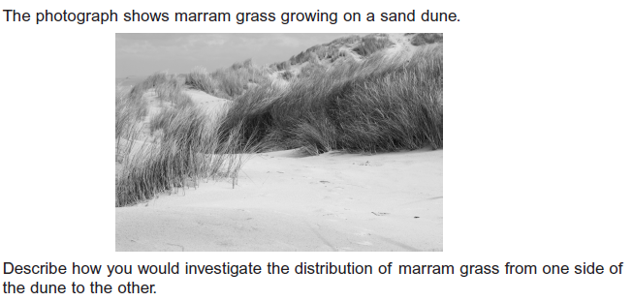
9.


Capture/recapture activity
You will need a box of matches and a felt pen to complete this activity.

- Remove 10 matches from the box and mark them with a felt pen.
- Return the marked matches to the box.
- Shake the box to mix up the matches.
- Remove 20 matches from the box and count the number of marked matches, recording the number of marked matches in the table below.
- Estimate the size of the match population (N) using the formula:

n1 = the first catch of 10 marked matches.
n2 = the second catch of 20 matches.
m = the number of marked matches in the second catch.

- Repeat this process three more times and record your results in the table below.

Sample | 1 | 2 | 3 | 4
n1 x n2 | 10 x 20
m
estimated match population

Questions
- a) How many matches are in the box?

b) How does this figure compare with the estimated size of the match population?

- In a population study of bandicoots, nine bandicoots were caught, tagged and released. At a later date, fresh traps were set and a total of twelve bandicoots were caught, six of which had tags. Calculate the population size at this time.
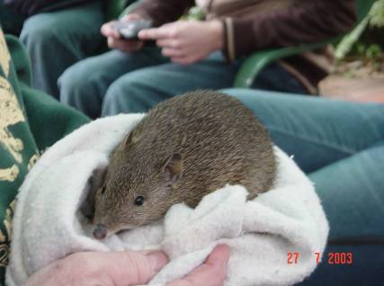
Photo courtesy of Leonie Wilson, SIDE
N=9x
6
108
=
6
=18bandicoots
12
- In order to manage fish stocks, it is important to estimate the size of the population at a given time. In a population study of the Tasmanian rainbow trout, 77 rainbow trout were caught, tagged and released from one lake. Several days later, 92 were caught, 32 of which had tags. Estimate the size of the trout population at this time.

- Give two reasons why an ecologist would need to measure the number of individuals in an animal or plant population.

- Why do ecologists use sampling techniques when measuring populations?

- What factors should be considered when deciding on a sampling technique to estimate population size or density? Give reasons for your answer.

- Which method would you use to estimate or identify each of the following? Give a reason for your choice of method for each question.
  - The population of an Australian endangered mammal such as the western barred bandicoot.
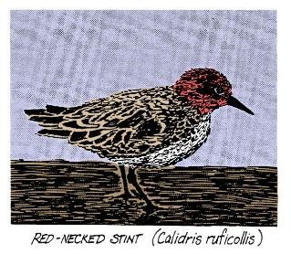

  - The population density of red-necked stints on the shore.

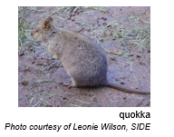
  - The population of quokkas on Rottnest Island.

  - The species of phytoplankton present in the open ocean.

  - The density of a population of sedentary animals such as coral.

  - The number of species of small birds present in a woodland.

- The marine iguana (Amblyrhynchus cristatus) is a species of lizard that is found on the Galapagos Islands.
  - Describe how you could use the capture-recapture method to estimate the number of marine iguana on one of these islands.

Stomatitis is an infection of the mouth which can lead to further complications and even death of individuals within marine iguana populations. Scientists were interested in investigation factors that made iguanas susceptible to the infection and the prevalence of the condition across the islands. They sampled populations by collecting iguanas from a large number of sites across the islands.

  - Explain the importance of collecting lizards from a large number of sites.

  - Describe one method scientists could use to ensure the sites were chosen without bias.

- Students on a field trip were fortunate to see a Thorny Devil, a type of lizard. The teacher explained that at the beginning of 2018 the reserves Thorny Devil population was 77. She also explained that there were 11 births, 5 deaths, 11 emigrated and 3 immigrated.
- Assist the students to find the:

- Size of the Thorny Devil population at the end of the 2018.

- The percentage change in population size.

- The students felt that the capture/recapture technique (also known as mark and release) may be a useful method to estimate the Thorny Devil population. Describe the technique.

- State two (2) factors that may lead to misleading estimates of the lizard population size.

- Recent technological advances have enabled researchers to remotely monitor species. Explain how this can be achieved.

